REVISIONS

REV # | ECN # | Description of Change | Engineer | Approved | Date
1 | NDI | New Document | EPF | SJS | 09/11/20

Description

System Master Controller Interface Design Description

Contents
1.0 INTRODUCTION AND OVERVIEW 3
1.1 Purpose 3
1.2 Responsibility 3
1.3 Definitions and Acronyms 3
1.4 References 3
1.5 Product Overview 3
2.0 Firmware upgrade procedure 3
2.1 Firmware upgrade using SMC Verifier 4
2.2 Firmware upgrade using LMFlashProgrammer 5
2.3 Firmware upgrade using Uniflash 6.1.0 8
2.3.1 Erase Entire Flash 13

INTRODUCTION AND OVERVIEW

Purpose
This document describes the procedures used to upgrade the firmware on the System Master Controller.

Responsibility
The Design Engineer responsible for the product is responsible to keep this document accurate and make sure that all engineers working on various aspects of the product always have the latest copy to work from.

Definitions and Acronyms
CMS | Cabin Management System
CAN | Controller Area Network
MRB | Mini Relay Box
MRC | Mini Relay Controller = Same as MRB

References
Product Specification for System Master Controller, DWG 107830PS

Product Overview
The ALTO Mini Relay Control is a small module that provides high current switch capabilities to the CSS keypads. It incorporates a CAN bus interface for allowing remote control feature.

Firmware upgrade procedure

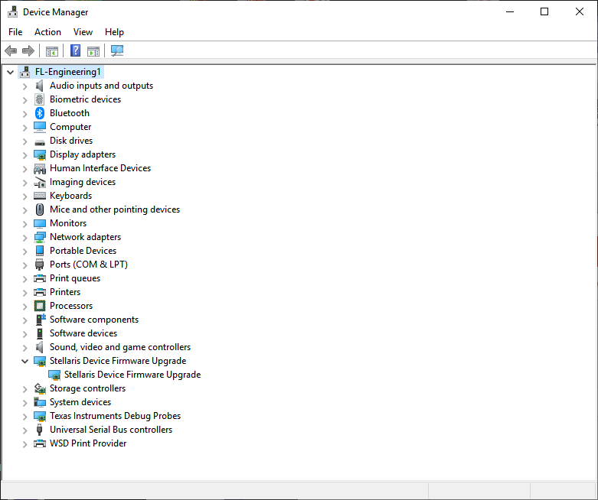

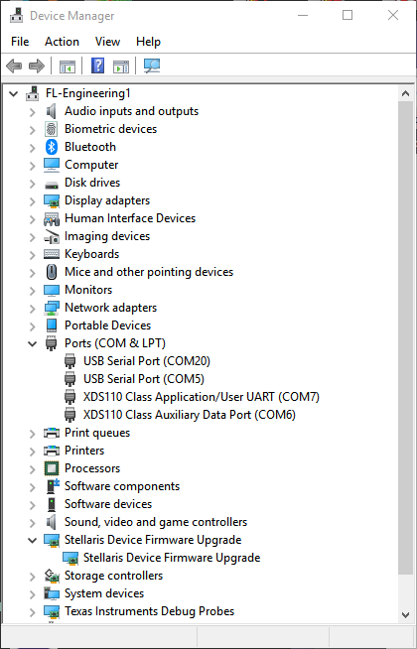 | 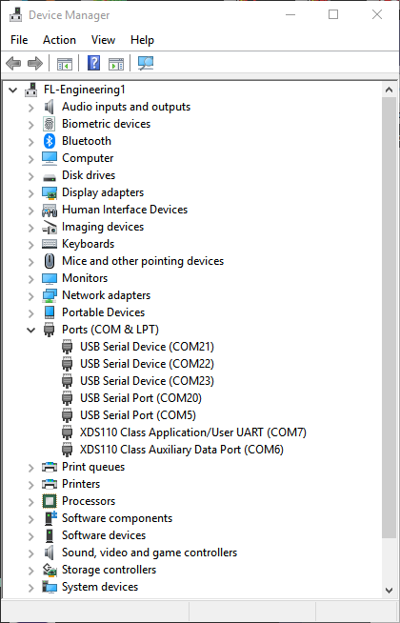

Firmware upgrade using SMC Verifier
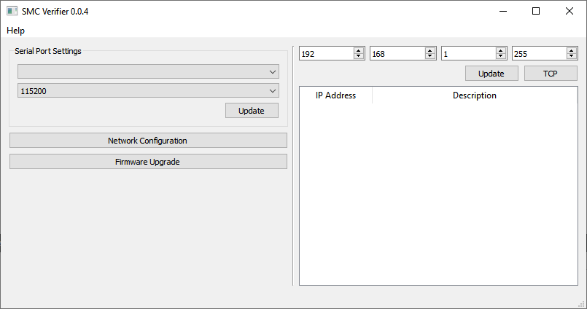

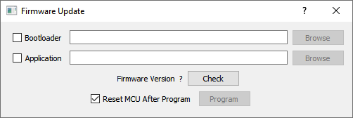

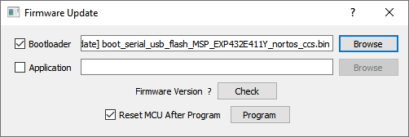

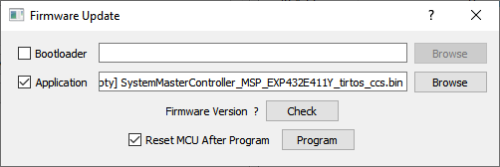

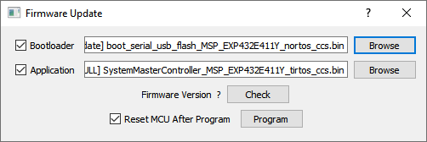

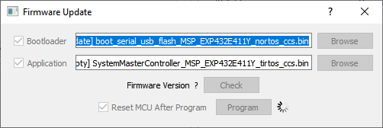

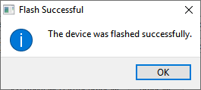

Firmware upgrade using LMFlashProgrammer

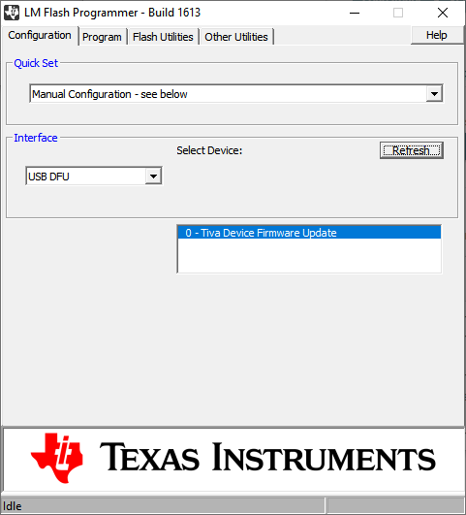

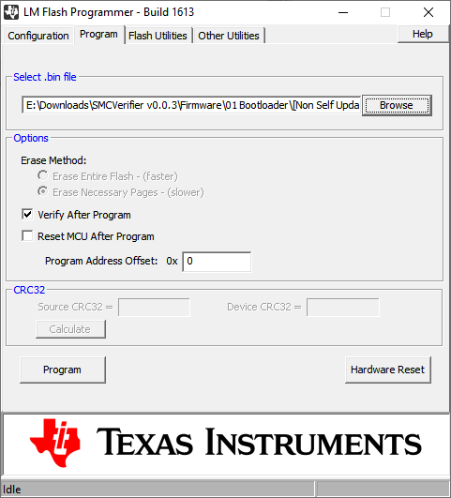

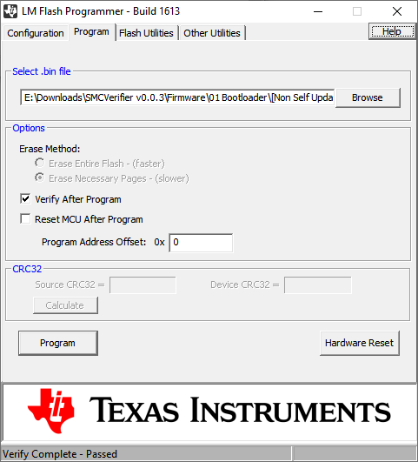

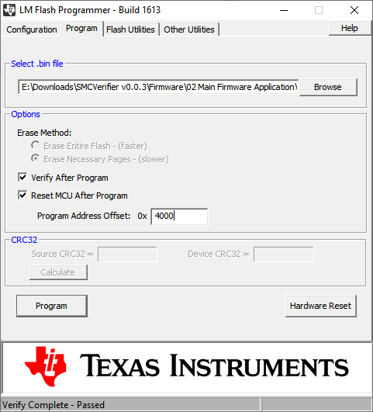

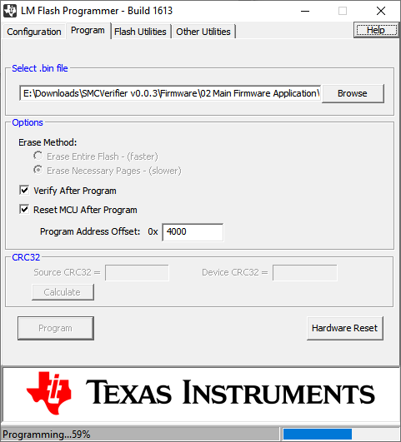

Firmware upgrade using Uniflash 6.1.0

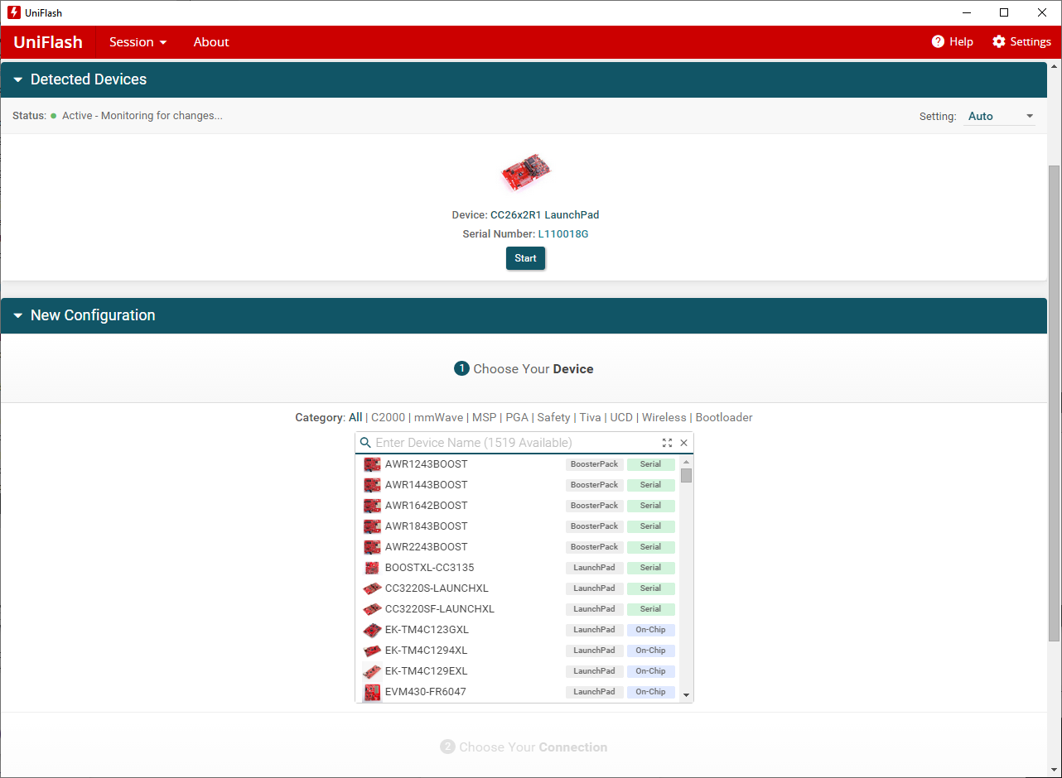

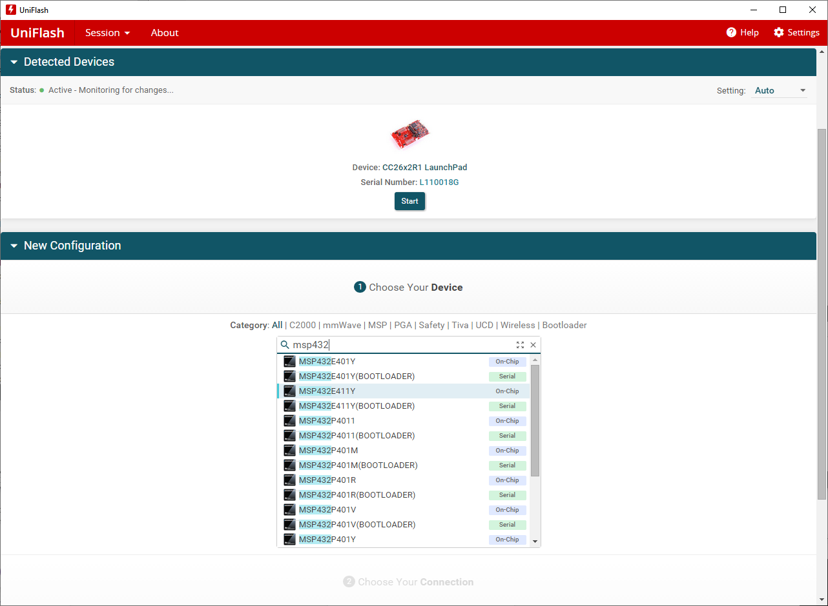

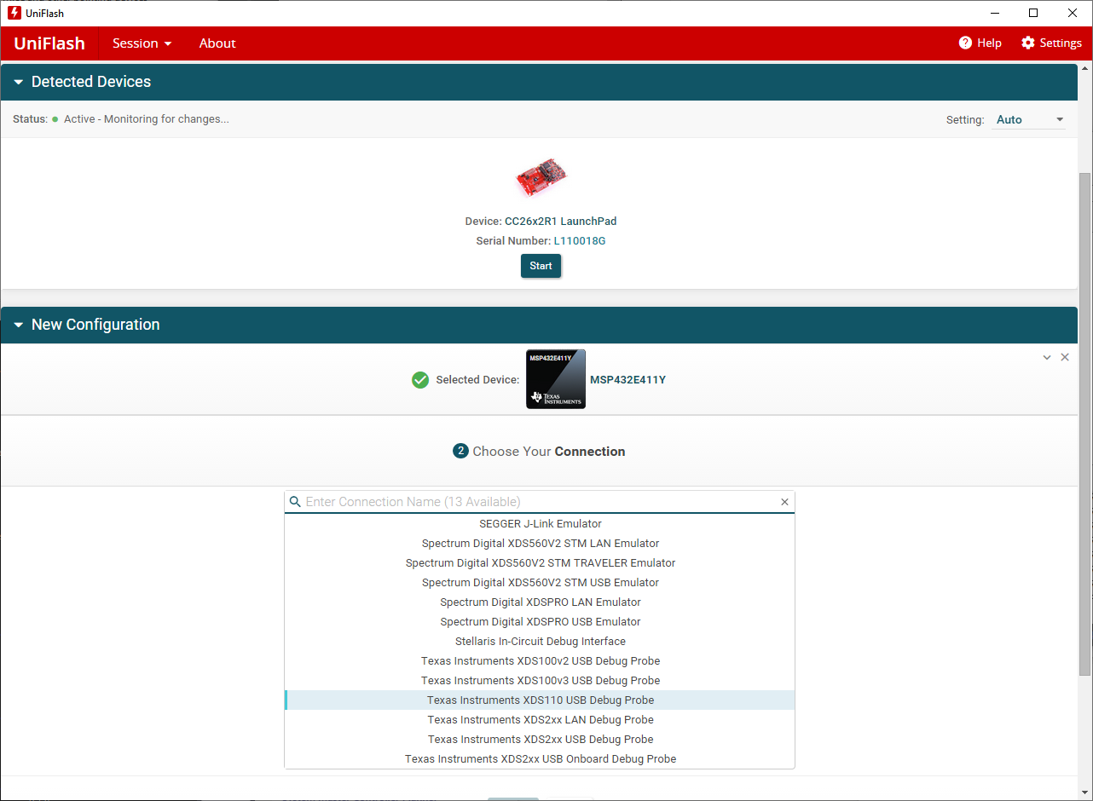

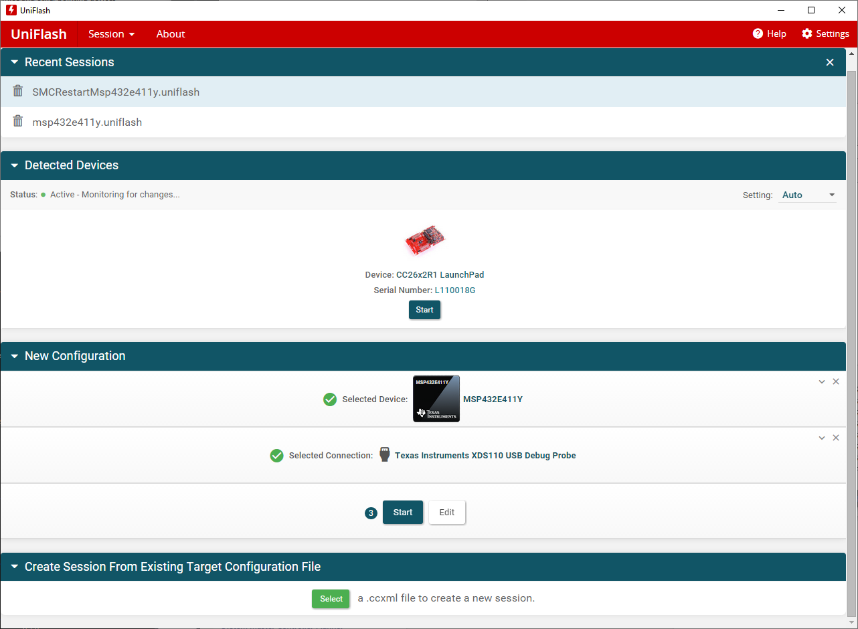

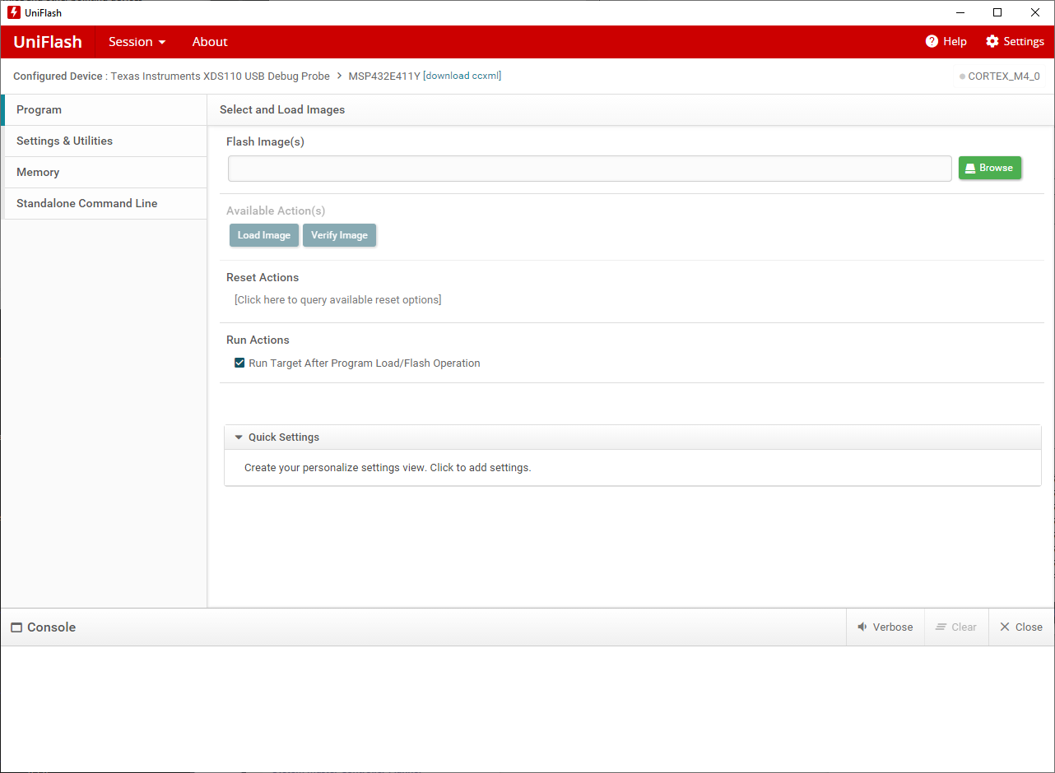

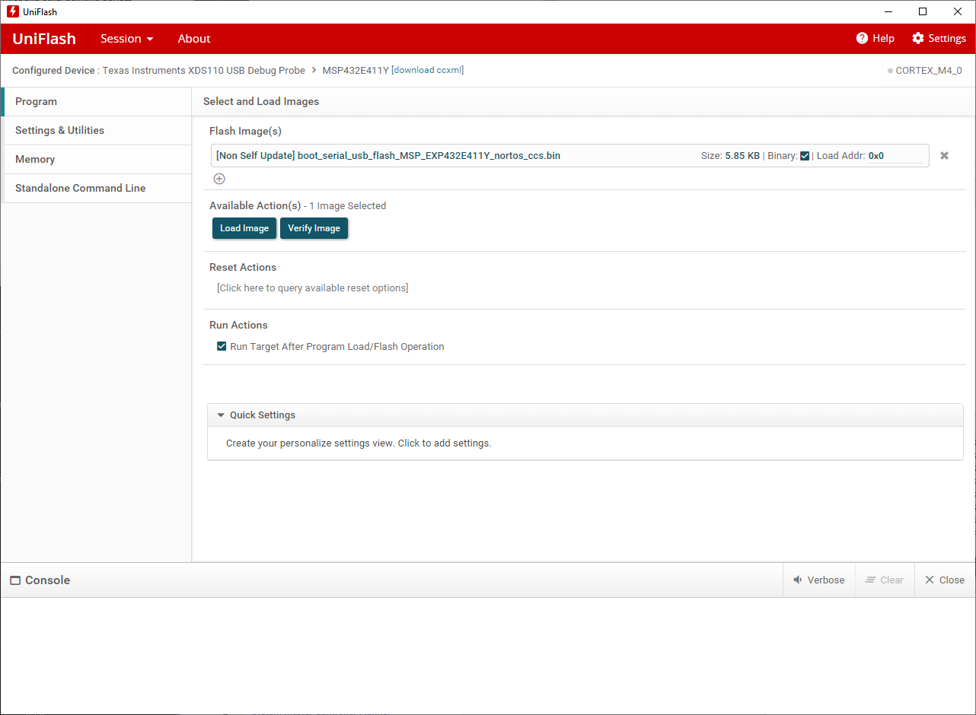

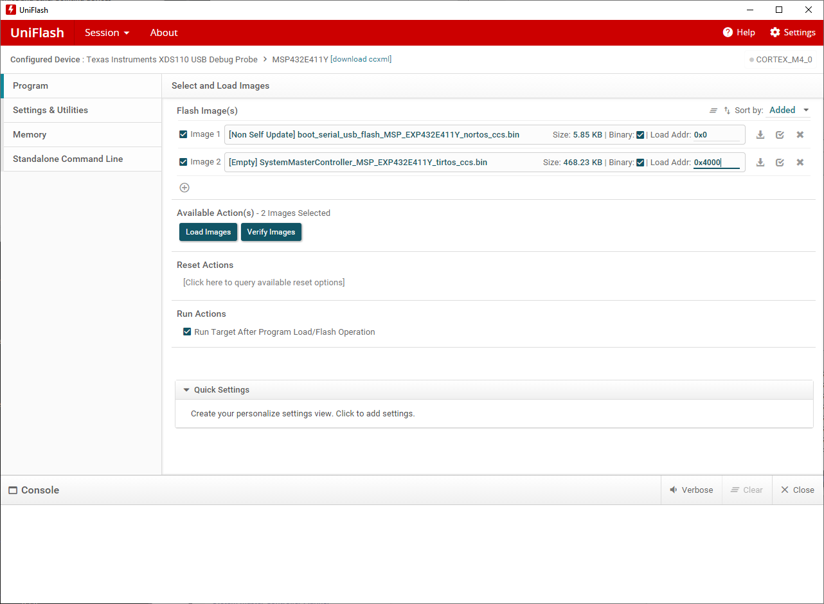

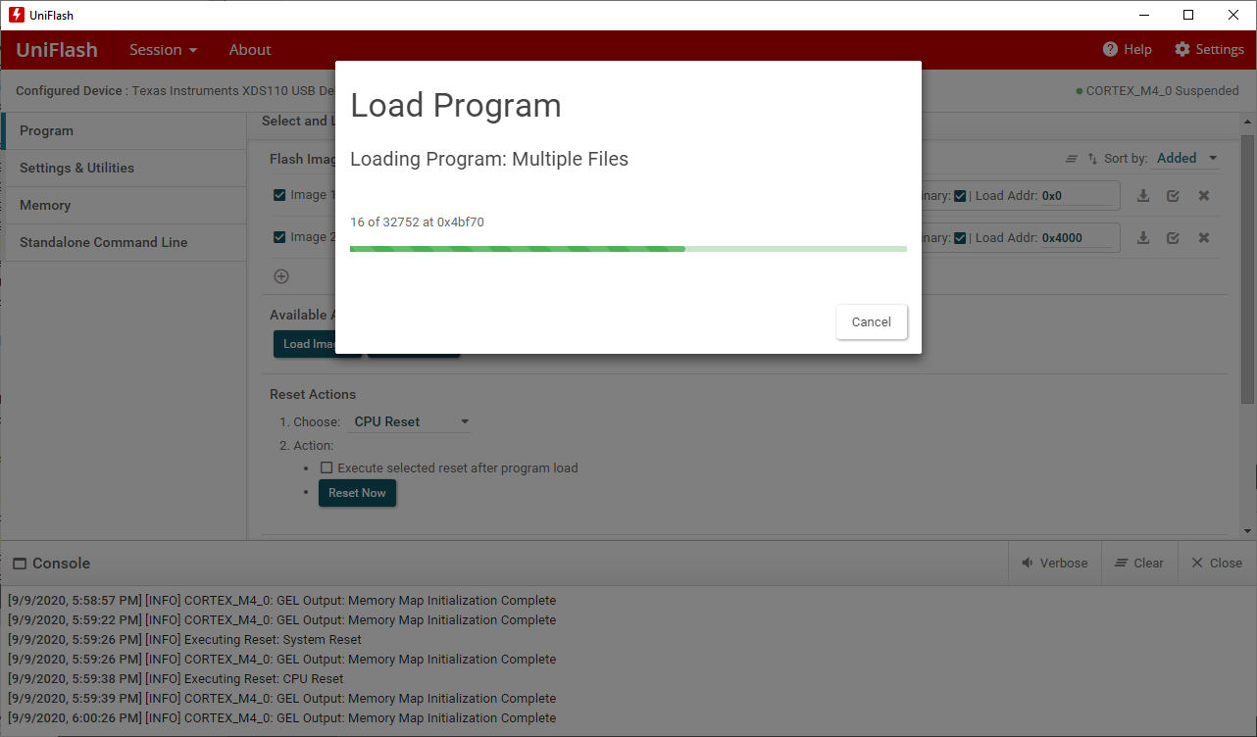

Erase Entire Flash
